#
# 20190117
# SD#1352953

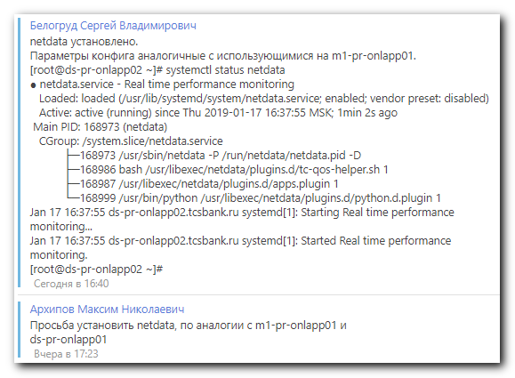

[root@m1-pr-onlapp01 ~]# ls /root/netdata-1.10.1-1.el7.centos.x86_64.rpm
/root/netdata-1.10.1-1.el7.centos.x86_64.rpm
[root@m1-pr-onlapp01 ~]# scp /root/netdata-1.10.1-1.el7.centos.x86_64.rpm bsv@ds-pr-onlapp02:/tmp/

[root@ds-pr-onlapp02 ~]# mkdir -p ~/work/20190117-1645
[root@ds-pr-onlapp02 ~]# cp /tmp/netdata-1.10.1-1.el7.centos.x86_64.rpm ~/work/20190117-1645/

[root@ds-pr-onlapp02 ~]# vim /etc/netdata/netdata.conf
[root@ds-pr-onlapp02 ~]# ip -f inet addr | grep inet
inet 127.0.0.1/8 scope host lo
inet 10.217.111.20/24 brd 10.217.111.255 scope global em3
inet 10.217.109.20/24 brd 10.217.109.255 scope global team0.2709
inet 10.217.110.20/24 brd 10.217.110.255 scope global team0.2710
[root@ds-pr-onlapp02 ~]# ip route | grep default
default via 10.217.109.254 dev team0.2709
[root@ds-pr-onlapp02 ~]# vim /etc/netdata/netdata.conf

[root@ds-pr-onlapp02 ~]# cat /etc/netdata/netdata.conf
# netdata configuration
#
# You can download the latest version of this file, using:
#
# wget -O /etc/netdata/netdata.conf http://localhost:19999/netdata.conf
# or
# curl -o /etc/netdata/netdata.conf http://localhost:19999/netdata.conf
#
# You can uncomment and change any of the options below.
# The value shown in the commented settings, is the default value.
#

[global]
run as user = netdata

# the default database size - 1 hour
history = 28800

# by default do not expose the netdata port
bind to = 10.217.109.20

[web]
web files owner = root
web files group = netdata
You have new mail in /var/spool/mail/root
[root@ds-pr-onlapp02 ~]#

[root@ds-pr-onlapp02 ~]# service netdata status
Redirecting to /bin/systemctl status netdata.service
● netdata.service - Real time performance monitoring
Loaded: loaded (/usr/lib/systemd/system/netdata.service; disabled; vendor preset: disabled)
Active: inactive (dead)
[root@ds-pr-onlapp02 ~]# service netdata start
Redirecting to /bin/systemctl start netdata.service
[root@ds-pr-onlapp02 ~]# service netdata status
Redirecting to /bin/systemctl status netdata.service
● netdata.service - Real time performance monitoring
Loaded: loaded (/usr/lib/systemd/system/netdata.service; disabled; vendor preset: disabled)
Active: active (running) since Thu 2019-01-17 16:37:55 MSK; 5s ago
Process: 168968 ExecStartPre=/bin/chown -R netdata:netdata /var/cache/netdata (code=exited, status=0/SUCCESS)
Process: 168966 ExecStartPre=/bin/mkdir -p /var/cache/netdata (code=exited, status=0/SUCCESS)
Main PID: 168973 (netdata)
CGroup: /system.slice/netdata.service
├─168973 /usr/sbin/netdata -P /run/netdata/netdata.pid -D
├─168986 bash /usr/libexec/netdata/plugins.d/tc-qos-helper.sh 1
├─168987 /usr/libexec/netdata/plugins.d/apps.plugin 1
└─168999 /usr/bin/python /usr/libexec/netdata/plugins.d/python.d.plugin 1

Jan 17 16:37:55 ds-pr-onlapp02.tcsbank.ru systemd[1]: Starting Real time performance monitoring...
Jan 17 16:37:55 ds-pr-onlapp02.tcsbank.ru systemd[1]: Started Real time performance monitoring.
[root@ds-pr-onlapp02 ~]#

[root@ds-pr-onlapp02 ~]# systemctl enable netdata
Created symlink from /etc/systemd/system/multi-user.target.wants/netdata.service to /usr/lib/systemd/system/netdata.service.
[root@ds-pr-onlapp02 ~]#

[root@ds-pr-onlapp02 ~]# systemctl status netdata
● netdata.service - Real time performance monitoring
Loaded: loaded (/usr/lib/systemd/system/netdata.service; enabled; vendor preset: disabled)
Active: active (running) since Thu 2019-01-17 16:37:55 MSK; 1min 2s ago
Main PID: 168973 (netdata)
CGroup: /system.slice/netdata.service
├─168973 /usr/sbin/netdata -P /run/netdata/netdata.pid -D
├─168986 bash /usr/libexec/netdata/plugins.d/tc-qos-helper.sh 1
├─168987 /usr/libexec/netdata/plugins.d/apps.plugin 1
└─168999 /usr/bin/python /usr/libexec/netdata/plugins.d/python.d.plugin 1

Jan 17 16:37:55 ds-pr-onlapp02.tcsbank.ru systemd[1]: Starting Real time performance monitoring...
Jan 17 16:37:55 ds-pr-onlapp02.tcsbank.ru systemd[1]: Started Real time performance monitoring.
[root@ds-pr-onlapp02 ~]#

[root@ds-pr-onlapp02 ~]# netstat -nlptu | grep -ie "netdata"
tcp 0 0 127.0.0.1:8125 0.0.0.0:* LISTEN 168973/netdata
tcp 0 0 10.217.109.20:19999 0.0.0.0:* LISTEN 168973/netdata
tcp6 0 0 ::1:8125 :::* LISTEN 168973/netdata
udp 0 0 127.0.0.1:8125 0.0.0.0:* 168973/netdata
udp6 0 0 ::1:8125 :::* 168973/netdata
[root@ds-pr-onlapp02 ~]#

http://ds-pr-onlapp02:19999/
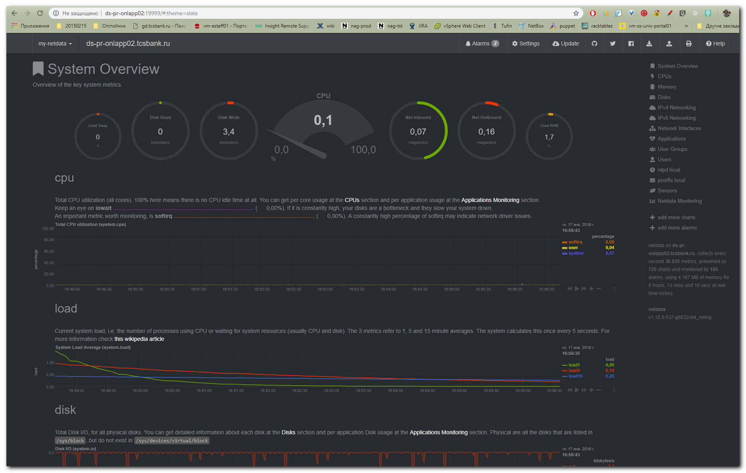

https://ruhighload.com/%D0%A0%D0%B0%D1%81%D0%BF%D1%80%D0%B5%D0%B4%D0%B5%D0%BB%D0%B5%D0%BD%D0%BD%D1%8B%D0%B9+%D0%BC%D0%BE%D0%BD%D0%B8%D1%82%D0%BE%D1%80%D0%B8%D0%BD%D0%B3+%D0%B8+%D0%B4%D0%B8%D0%B0%D0%B3%D0%BD%D0%BE%D1%81%D1%82%D0%B8%D0%BA%D0%B0+%2F+netdata

